NC Clean Economy Summit Speaker Bios

Breakout Session Bios - Energy Planning for NC’s Clean Energy Future

 | Miriam Makhyoun is the Chief Executive Officer of EQ Research, a national energy consulting firm known for Policy Vista™, an online platform tracking and analyzing state regulatory proposals, state legislation, general rate cases, RPS and resource planning market data, electric vehicle regulation, and low carbon fuel policy. Miriam was a Power Supply Contracts Manager at MCE, California’s first Community Choice Aggregation Program, where she managed MCE’s 2018 Energy Storage Request for Offer process. Other experience includes portfolio management for Pacific Gas & Electric (PG&E) procuring Resource Adequacy capacity and carbon compliance instruments. Before PG&E, Miriam provided customized research to members of the Smart Electric Power Alliance and the North Carolina Sustainable Energy Association.
 | Claire Williamson joined the N.C. Justice Center in February 2020 as the Energy Policy Advocate. Prior to working at the Justice Center, Claire helped implement renewable energy and energy saving programs to District of Columbia residents and business by providing market analysis and business solutions. Claire holds Master of Science in Environmental Science and Master of Public Affairs degrees from Indiana University, Bloomington and a Bachelor of Arts degree in Environmental Studies from American University.
 | Maggie Clark is the Southeast State Affairs Senior Manager at Solar Energy Industries Association (SEIA). She joined SEIA in 2016 and oversees regulatory and legislative engagement in the region. She also manages the SEIA Siting and Permitting Committee with an emphasis on private land development. Prior to SEIA, Maggie worked in Government Affairs at the NC Sustainable Energy Association. Maggie received her B.A. in Public Policy from the University of North Carolina at Chapel Hill.
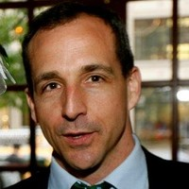 | Locke Raper is Director, Strategic Verticals at GridBridge, Inc. He leads business development, marketing and sales of GridBridge's energy efficiency technology into the production agriculture market and other verticals.

Breakout Session Bios - Electrifying Transportation

 | Stan Cross is Electric Transportation Policy Director for the Southern Alliance for Clean Energy where he leads electric transportation policy and utility reform efforts across the Southeast. Previously, Stan co-founded Brightfield Transportation Solutions—an Asheville start-up that designs and deploys solar-integrated electric vehicle charging stations. He also served as a transportation electrification consultant for the Cities of Raleigh and Charlotte, NC, and the Energy Foundation. Stan’s decade of experience in the electric transportation trenches demonstrates that the development of innovative and supportive state, municipal and utility policies is central to unlocking the electric transportation market.
 | Terry Travis is managing partner of EVNoire – Mobility Intelligence Group, a consulting group that works in the area of Transportation, Energy & Environmental Health equity and has compiled extensive data on Mobility needs within diverse communities. He is a subject matter expert consulting on strategies to engage disadvantaged communities in the areas of Mobility and clean/sustainable energy platforms as well as highlighting the financial and public health benefits of driving next-generation zero emission vehicles. He has led collaborations with non profits, government agencies, public health groups, regional and national organizations as well as manufacturers to expand EV market share
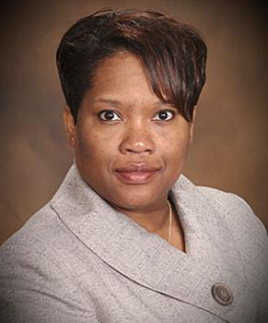 | Marilynn Marsh-Robinson is the Manager of Partnerships & Outreach in EDF’s Energy program in Raleigh. Marilynn works with partners to develop holistic, sustainable energy solutions that incorporate socioeconomic factors. She collaborates with electric cooperatives, transit agencies, local governments and faith-based partners on electrification and energy efficiency efforts. Marilynn also has experience with environmental justice and equity issues. She serves on the North Carolina Department of Environmental Quality Environmental Justice and Equity Advisory Board and is a member of the planning committee of North Carolina Environmental Justice Network. She previously served on the North Carolina Conservation Network board.
Chris Nevers is Director of Environmental Engineering & Policy at Rivian. Chris joined Rivian in February of 2020 to help implement the policies needed to expand electrification and to expand Rivian’s role in creating a sustainable future.
Prior to joining Rivian, Chris worked for the Alliance of Automobile Manufacturers, EPA’s Office of Transportation and Air Quality, and Chrysler. Whether it be from the manufacturer, government, or trade association standpoint, his focus has been on vehicle emissions, fuel economy, and electrification.
 | Brita Formato is Managing Director of Transportation Electrification at Duke Energy. She leads Duke’s business ventures in transportation electrification across the enterprise. Brita‘s team develops and executes company strategy on transportation electrification within Duke Energy’s utility footprint and nationally across emerging customer products and services with a mission to “make it easy to drive electric.” Brita is a 25 year energy industry executive with experience from working for Equinor, ExxonMobil and Duke Energy. A native of Norway, Brita earned an MBA from the Columbia Business School at Columbia University in New York, NY, and holds a Bachelor of Arts degree in economics from Eckerd College in St. Petersburg, FL.

Breakout Session Bios - Building a Resilient NC and Growing our Outdoor Industry

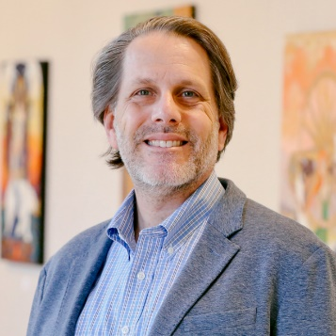 | Dave Petri is the founder and principal consultant at Cynosura Consulting – a marketing consulting firm committed to guiding clients in creating authentic branding strategies with an emphasis on sustainability and transparency. In addition, Dave serves on the Board of Directors for the North Carolina Outdoor Recreation Coalition. Dave is an outdoor industry professional with 30 years of proven leadership experience in directing diverse and creative cross-functional teams to achieve success. He is a highly regarded marketing and sustainability professional as well as an active outdoorist with a personal passion for outdoor recreation advocacy and public lands protection.
 | Sherri White-Williamson is Environmental Justice Policy Director at N.C. Conservation Network and leads the organization’s efforts to connect impacted community-led campaigns and organizations with decision-makers. Prior to joining NC Conservation Network, Sherri worked at the U. S. Environmental Protection Agency in the Office of Environmental Justice. Sherri also currently serves as a Board member of the Rural Empowerment Association for Community Help (R.E.A.C.H.). In her spare time, Sherri enjoys baking, DIY projects, and playing with her dog. Sherri has been with NC Conservation Network since 2019.
 | Amy Allison is Director Outdoor Recreation Industry Office at the Economic Development Partnership of NC (EDPNC). Amy is responsible for promoting the state’s tremendous outdoor recreation industry assets. She collaborates with existing attractions, businesses, and communities while also identifying and recruiting companies interested in relocating or expanding to North Carolina. Before joining EDPNC, Allison was marketing director for Eagles Nest Outfitters in Asheville. Allison also served at Leave No Trace, as a wilderness guide, is co-founder and board chairwoman of the Outdoor Gear Builders of WNC, and on the advisory council of the Growing Outdoors Partnership, which includes more than a dozen nonprofits, businesses, academic institutions, and government agencies working to expand the outdoor industry across 25 counties in Western North Carolina.
 | William J. Barber III is the Strategic Partnerships Manager for the Climate Justice Initiative at The Climate Reality Project. William currently serves as a member of the NC DEQ Secretary’s Environmental Justice and Equity Advisory Board, as well as co-chair for the NC Poor People’s Campaign Ecological Devastation committee. William attended college at North Carolina Central University, where he completed an undergraduate degree in environmental physics. He received his J.D. from UNC School of Law. He is interested in exploring how disruptive technology and impact investing can help fuel a just transition and promote economic opportunity for low income communities and communities of color. He believes there is a critical role for Southern leadership in the conversation around our nation’s transition to a clean economy. William has given talks on climate justice in several venues including the Climate Reality Project: Atlanta Climate Reality Leadership Corps Training, the Think 100% #ClimateFriday Broadcast, the Spalding International Brain Trust, and the Carnegie Council for Ethics in International Affairs.
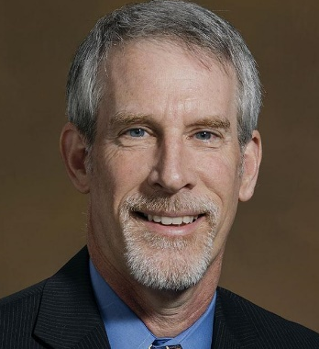 | D. Reid Wilson is the chief deputy secretary of the North Carolina Department of Natural and Cultural Resources. Reid has a wealth of experience in land conservation, environmental protection, and government and nonprofit leadership to the department. From 2003 – 2017, he was the executive director of the Conservation Trust for North Carolina, a statewide nonprofit that advances land conservation by protecting lands along the Blue Ridge Parkway, assisting 24 local land trust organizations, and connecting people to the outdoors. Under his leadership, CTNC became a national leader in bringing greater diversity and engagement with young people to conservation. Prior to that, he served for nearly eight years at the U.S. EPA as a political appointee in the Clinton administration, first as the agency’s public liaison director, then deputy chief of staff, and finally chief of staff under administrator Carol M. Browner.

